**Fail Bug -1**

“The “Rate now “button does not work “

*Description*

*Steps*

1. Open Screen Recorder

2. Click “Rate Now “in top screen

*Expected Result*

App opens in Play Store with 5 stars displayed for rating

*Actual Result*

“Rate Now “window closes and nothing else happens

Severity: medium (there is no work around but the user can still write “1 star “in the comments )

*Notes*: No workaround to rate the app

Fail Bug -2

“Text Box does not appear in “Face Recorder “feature”

*Description*

*Steps*

1. Open Screen Recorder

2. Click “Record” button

3. Scroll down the status bar

4. Click on Recorder Face

5. Click “Allow”

*Expected Result*

Window opens consisting of camera and text box

*Actual Result”

Text box does not appear

Severity: High

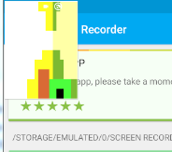

Fail Bug-3

“No low battery indication when simulating low voltage, no “battery” will run out soon message “

*Description*

*Steps*

1. Open Screen Recorder

2. Click “Record” button

3. Open”…”options button

4. Click “Battery”

5. Define “None” in charger field

6. Define 14% in the battery field

*Expected Result*

"14%" displays in the battery field and on the phone's screen

"Battery will run out soon" message

*Actual Result*

No message or visual Indication of low battery appears on screen

Severity: Medium

*Notes*: Does not happen in other Versions

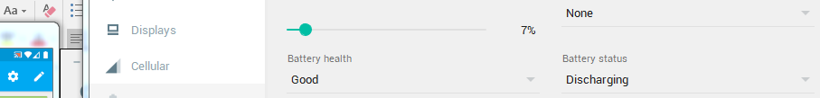

Fail Bug -4

“Grey ruler does not function properly”

*Description*

*Steps*

1. Open Screen Recorder

2. Click “Record” button

3. Click stop after 10 seconds

4. Click “Trim” button

5. Move the grey ruler to the 7th second

*Expected Result*

Playback plays from 7th second

*Actual Result*

The playback stops, play button displays with window with strange language in the background

Severity: High

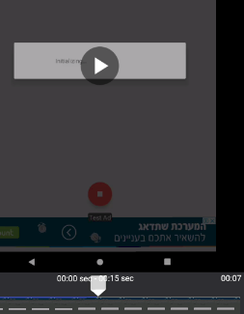

*Notes*: Happens when moving the ruler back as well

Fail Bug – 5

“Fail to create and edited recording “

*Description*

*Steps*

1. Open Screen Recorder

2. Click “Record” button

3. Click stop after 10 seconds

4. Click “Trim” button

5. Put the left red arrow on the 3rd second

6. Put the right red arrow on the 7th second

7. Click “Save“

*Expected Result*

The recording is saved with the edited settings instead of the existing recording.

*Actual Result*

Additional recording appears with the timer displaying 00:00 seconds, the original recording remains

Severity: High

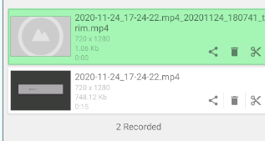

*Notes*: The edited recording opens and shows 00:00 with no playback

Fail Bug-6

“Share Button on the Saved recording fails “

*Description*

*Steps*

1. Open Screen Recorder

2. Click “Record” button

3. Click “Stop” after 2 seconds

4. Click “Share”

*Expected Result*

Window with platforms to share with opens

*Actual Result*

App Closes

Severity: Medium

Fail Bug -7

“Unsatisfying UX due to multiple ads in the app”

*Description*

*Steps*

1. Open Screen Recorder

2. Click on “=” Menu icon

3. Click “Wi Fi transfer

*Expected Result*

Wi Fi transfer page opens fast

, displaying Wi Fi address for phone to computer connection

*Actual Result*

An ad appears

Severity: Medium

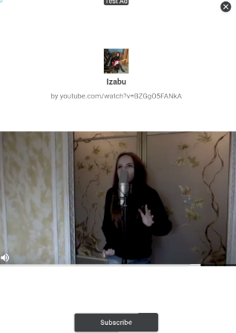

*Notes*: Possible to wait through the ad and close it with “x” to reach the desired page, “Back” arrow button on the phone does not work

Happens every time when clicking “Wi Fi “transfer option, happens when clicking “Settings” option as well. Ads appear randomly when using the app’s interface. Ads on main screen are also appearing non-stop despite closing them repeatedly. Also sometimes happens when opening the app.



Fail Bug-8

“Incorrect IP address displays on Wi Fi transfer page-Missing number in the IP address”

*Description*

*Steps*

1. Open Screen Recorder

2. Click on”=” Menu icon

3. Click “Wi Fi transfer

*Expected Result*

Wi Fi transfer page opens fast

, displaying Wi Fi address for phone to computer connection

*Actual Result*

An ad appears, Wi Fi address is shown but is missing numbers

Severity: Very High

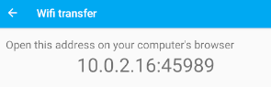

Fail Bug- 9

“Sound recorder button not enabled by default in settings “

*Description*

*Steps*

1. Open Screen Recorder

2. Click on “=” Menu icon

3. Click on” Settings” option

*Expected Result*

Button “Recorder Sound” is enabled by default

*Actual Result*

Button is disabled

Severity: Medium

*Notes*: No message appeared, possible to disable despite that

Fail Bug – 10

“Recorder Sound button functions while recording “

*Description*

*Steps*

1. Open Recorder Sound

2. Click “Record” button

3. Press the Setting icon

4 .Click the Recorder Sound button

*Expected Result*

Button is not clickable

*Actual Result*

Button is clickable

Severity: Medium

Fail Bug – 11

“Recording does not stop on shake “

*Description*

*Steps*

1. Open Recorder Sound

2. Click “settings” icon

3. Click “Stop on shake”

4. Click “Back

5. Click “Record” button

6. Press and hold on the emulator’s top panel (left mouse button press and hold)

7. Drag the panel left-right in quick motions imitating shaking the phone

*Expected Result*

Recording stops

*Actual Result*

Recording does not stop

Severity: Medium

Fail Bug -12

“Rate 5 Stars “option does not work “

*Description*

*Steps*

1. Open Recorder Sound

2. Click “=” icon

3. Click “Rate 5 stars”

*expected result*

App page opens in google play, with 5 starts rating available to choose from

*Actual result*

Menu bar closes, app is back to main page

Severity: medium

Fail Bug -13

“Save Privacy Policy “button does not work

*Description*

*Steps*

1. Open Recorder Sound

2. Click “=” icon

3. Click “About

4. Click the “=” button to save Privacy Policy

*Expected result*

Policy is saved to the phone

*Actual result*

The button does not function

Severity: low (In my opinion UX does not decrease due to this)

Fail Bug -14

*Description*

*Steps*

1. Open Recorder Sound

2. Click “=” icon

3. Click “more apps”

*Expected Result*

Page opens with more apps associated with the developer

*Actual Result*

The app opens main screen

Severity: Medium